Newsletter
No 201 October 2017
General Secretariat of the CSSF
283, route d’Arlon, L-1150 Luxembourg
Postal address: L-2991 Luxembourg
Tel.: (+352) 26 251-2560
Email: direction@cssf.lu
Website : http://www.cssf.lu

NEWS

Annual report 2016 in English
The CSSF published the English version of its 2016 annual report. A PDF and an online flip book are available on the website at:
http://www.cssf.lu/en/documentation/publications/annual-reports/news-cat/567/.

HUMAN RESOURCES

CSSF staff evolution
Since the publication of the last Newsletter, the CSSF has recruited 12 new agents who were assigned to the following departments:

UCI departments
Fouad EL BERKANI
Maximilien SAGRILLO

Supervision of securities markets departments
Tanja EWERT
Iwona SEREDYNSKA

On-site inspection
Grégory BAYLE
Alix HAMMOND
Guillaume MARCHAL
Maria MARTINS
Agnès OSVILLE

Personnel, administration and finance
Elza MARQUES

Information systems of the CSSF (IT)
Lucie EVORA LOPES
Vito DE MICHELE
Following the departure of one agent, the CSSF counts 746 agents of which 399 are men and 347 are women (1 October 2017).

WARNINGS

Warning published by the CSSF
Since the publication of the last Newsletter, a warning concerning the activities of an entity named DBL Asset Management S.A. was published by the CSSF:
http://www.cssf.lu/fr/consommateur/avertissements/news-cat/90/.

Warning issued by another authority
Since the publication of the last Newsletter, a warning concerning the activities of an entity named Pascal Grande Capital Partners was published by the British authority, the FCA.
https://www.fca.org.uk/news/warnings/pascal-grande-capital-partners-clone

Warnings published by IOSCO
Several warnings were published on IOSCO’s website at:
http://www.iosco.org/investor_protection/?subsection=investor_alerts_portal.

NATIONAL REGULATION

CSSF Regulation N° 17-03
The purpose of CSSF Regulation N° 17-03 is to set a countercyclical buffer rate for the fourth quarter of 2017. This countercyclical buffer rate applicable to the relevant exposures located in Luxembourg remains at 0%. CSSF Regulation N° 17-03 was published in the Journal Officiel du Grand-Duché de Luxembourg (Mémorial A, No 861 of 27 September 2017) and on the CSSF website (http://www.cssf.lu/en/supervision/banks/regulation/laws-regulations-and-other-texts/).

Circular CSSF 17/669
The purpose of Circular CSSF 17/669 is to draw the attention of the persons concerned to the joint guidelines on the prudential assessment of acquisitions and increases of qualifying holdings in the financial sector (JC/GL/2016/01) issued by the European Securities and Markets Authority (ESMA), the European Banking Authority (EBA) and the European Insurance and Occupational Pensions Authority (EIOPA). These guidelines entered into force on 1 October 2017 and the CSSF intends to comply with them.

Circular CSSF-CPDI 17/09
The purpose of Circular CSSF-CPDI 17/09 is to carry out a survey on deposits, and more particularly on covered deposits, as held by credit institutions incorporated under Luxembourg law, POST Luxembourg for its provision of postal financial services, and Luxembourg branches of credit institutions having their head office in a third country as at 30 September 2017.

BANKING REGULATION AND SINGLE SUPERVISORY MECHANISM

Single Supervisory Mechanism - European Central Bank (ECB)

Publications and Consultations
1 September 2017 – Letter from the Chair of the Supervisory Board to members of the European Parliament
The European Central Bank (ECB) has published a letter from the Chair of the Supervisory Board to members of the European Parliament in response to a written request in relation to oligopoly in the auditing sector.
20 September 2017 – ECB published opinion on proposals for the recovery and resolution of central counterparties (CCPs)
The ECB has published an opinion on proposals for the recovery and resolution of central counterparties (CCPs). The ECB supports the Commission’s initiative to establish a dedicated Union framework for the recovery and resolution of CCPs. However, it provides some suggestions to enhance the proposal, including aligning the proposal with what has been agreed and/or is under development at international level.
21 September 2017 – ECB issued draft consultation guide on bank licensing and fintech bank licensing
The ECB has issued a draft consultation guide on bank licensing and fintech licensing. The first draft guide sets out the general process and the requirements for the assessment of licence applications. The second draft guide is directed at entities with a fintech business model which are considering applying for a banking licence. The guides are based on policies agreed between the ECB and the national competent authorities for interactions with licence applicants. See also the Q&A document.
The consultation will run until 2 November 2017.
25 September 2017 – ECB Guide on materiality assessment (EGMA) - Materiality assessment for IMM and A-CVA model extensions and changes
The ECB has released its guide on materiality assessment for changes to counterparty credit risk models. The guide is aimed to assist significant institutions directly supervised by the ECB in their self-assessment of the materiality of changes and extensions to internal models used to calculate counterparty credit and credit valuation adjustment risks.

Interviews and speeches
5 September 2017 – “Banks must be allowed to fail” - Contribution by Danièle Nouy, Chair of the Supervisory Board of the ECB, for Handelsblatt conference brochure
5 September 2017 – “Restructuring, resolution and insolvency: shift of tasks from judicial to administrative authorities” – Discussant Remarks by Pentti Hakkarainen, Member of the Supervisory Board of the ECB, at the ECB Legal Conference, Frankfurt
6 September 2017 – “A penny for your thoughts – what’s on the mind of a supervisor?” - Speech by Danièle Nouy, Chair of the Supervisory Board of the ECB, at the Handelsblatt conference “Banken im Umbruch”
15 September 2017 – “Gaming the rules or ruling the game? – How to deal with regulatory arbitrage” - Speech by Danièle Nouy, Chair of the Supervisory Board of the ECB, at the 33rd SUERF Colloquium, Helsinki
15 September 2017 – “Banking supervision – is variety really the spice of life?” - Statement by Sabine Lautenschläger, Member of the Executive Board of the ECB and Vice-Chair of the Supervisory Board of the ECB, at the Eurofi Financial Forum, Tallinn
18 September 2017 – “Regulation, supervision and market discipline – striking a balance” - Statement by Sabine Lautenschläger, Member of the Executive Board of the ECB and Vice-Chair of the Supervisory Board of the ECB, at a conference hosted by the Financial Stability Institute,Basel
22 September 2017 – “The challenges and future of banking in the EU” - Discussant Remarks by Pentti Hakkarainen, Member of the Supervisory Board of the ECB, at the ESRB Annual Conference, Frankfurt
22 September 2017 – “The ECB and national supervisory authorities: cooperation and common challenges” – Speech by Ignazio Angeloni, Member of the Supervisory Board of the ECB, at the XXXI Convegno “Adolfo Beria di Argentine”, Courmayeur
27 September 2017 – “Too much of a good thing? The need for consolidation in the European banking sector” - Speech by Danièle Nouy, Chair of the Supervisory Board of the ECB, at the VIII Financial Forum, Madrid
28 September 2017 – “European banking supervision – achievements, challenges and the way forward” – Speech by Sabine Lautenschläger, Member of the Executive Board of the ECB and Vice-Chair of the Supervisory Board of the ECB, at the ESE Conference 2017, Vienna
29 September 2017 – “Banking union, three years on – has it lived up to its promises?” - Statement by Danièle Nouy, Chair of the Supervisory Board of the ECB, at the Single Resolution Board Conference, Brussels

Regulatory developments
19 September 2017 – Publications of the Regulation (EU) 2017/1538 of the European Central Bank of 25 August 2017 amending Regulation (EU) 2015/534 on reporting of supervisory financial information (ECB/2017/25)
19 September 2017 – Publications of the Regulation (EU) 2017/1539 of the European Central Bank of 25 August 2017 laying down the date of application of Regulation (EU) 2017/1538 amending Regulation (EU) 2015/534 on reporting of supervisory financial information (ECB/2017/25) to less significant supervised entities which are subject to national accounting frameworks (ECB/2017/26)
19 September 2017 – Publication of the Corrigendum to Commission Delegated Regulation (EU) 2017/565 of 25 April 2016 supplementing Directive 2014/65/EU of the European Parliament and of the Council as regards organisational requirements and operating conditions for investment firms and defined terms for the purposes of that Directive

European Commission

Publications
20 September 2017 – EU Commission released proposals to improve the mandates, governance and funding of the ESAs
The European Commission has released proposals to improve the mandates, governance and funding of the ESAs. The key features of the proposals are the following: (i) stronger coordination of supervision across the EU; (ii) extended direct capital markets supervision by ESMA – especially in the fields of capital market data, capital market entry, capital market actors and market abuses cases; (iii) improved governance and funding of the ESAs; and (iv) promoting sustainable finance and FinTech. Alongside these proposals, the Commission also announced plans to align the regulatory and supervisory treatment of certain large investment firms with the one applying to large credit institutions.
See also the EBA and ESMA public statements on the EU Commission proposals.

European Banking Authority (EBA)

Publications
Capital Requirements Directive and Regulation
11 September 2017 – EBA issues revised list of ITS validation rules
The European Banking Authority (EBA) has issued a revised list of validation rules in its implementing technical standards (ITS) on supervisory reporting, highlighting those which have been deactivated either for incorrectness or for triggering IT problems.
12 September 2017 – The EBA CRDIV CRR Basel III monitoring exercise shows further improvement of EU banks capital leverage and liquidity ratios
The EBA has published its twelfth Report of the CRDIV-CRR/Basel III monitoring exercise on the European banking system. This exercise presents aggregate data on EU banks’ capital, leverage, and liquidity ratios assuming full implementation of the CRD IV-CRR/Basel III framework. Overall, the results, based on data as of 31 December 2016, show a further improvement of European banks' capital positions, with a total average Common Equity Tier 1 (CET1) ratio of 13.4% (12.8% as of 30 June 2016). In terms of risk-weighted capital, the exercise estimated relatively low shortfalls of CET1 capital. The analysis of leverage ratio (LR) shows that there has been a continuous increase in recent periods. This exercise does not reflect any BCBS standards agreed since the beginning of 2016 or any other measures currently being considered by the BCBS.
26 September 2017 – EBA publishes guidance to further harmonise EU banks internal governance
The EBA has published its revised Guidelines on Internal Governance. These updated guidelines, which have been developed according to Article 74(3) of the CRD IV, aim at further harmonising institutions' internal governance arrangements, processes and mechanisms across the EU, in line with the new requirements in this area introduced in the CRD IV and also taking into account the proportionality principle. The updated guidelines put more emphasis on the duties and responsibilities of the management body in its risk oversight function, clarifying the role of their committees.
Bank Recovery and Resolution Directive
5 September 2017 – EBA publishes final technical standards on MREL reporting by resolution authorities
The EBA has published its final draft ITS specifying templates and procedures resolution authorities should follow when informing the EBA of the minimum requirement for own funds and eligible liabilities (MREL) that have been set for institutions under their jurisdiction. These standards, which have been developed according to Article 45(17) of the BRRD, are aimed to enable the EBA to monitor the consistency of MREL implementation across the EU.
Other
29 September 2017 – EBA issues Opinion on the design of a new prudential framework for investment firms
The EBA has published its Opinion on the design and calibration of a new prudential framework for investment firms, which aims to be specifically tailored to the needs of investment firms' different business models and inherent risks. The opinion includes a series of recommendations aiming to develop a single and harmonised set of requirements that are reasonably simple, proportionate and relevant to the nature of investment firms authorised to provide MiFID services and activities.
29 September 2017 – EBA and US Agencies conclude Framework Cooperation Arrangement on Bank Resolution
The EBA has signed a Framework Cooperation Arrangement with several US financial regulatory Agencies (e.g. the Federal Deposit Insurance Corporation, the Securities and Exchange Commission). The Framework Cooperation Arrangement lays out the basis for subsequent cooperation arrangements on bank crisis management and resolution between any of the EU Supervisory or Resolution Authorities and any of the participating US Agencies. This Framework Cooperation Arrangement has the objective to promote resolution planning and cooperation for cross-border institutions.

Consultations
Capital Requirements Directive and Regulation
19 September 2017 – EBA launches consultation on significant risk transfer in securitisation
The EBA has launched a public consultation on its discussion paper on significant risk transfer in securitisation. This work builds on the EBA’s monitoring activity of supervisory practices in the area of significant risk transfer, which the EBA started in 2014 with the publication of the EBA Guidelines on this topic. The discussion paper, which has been developed according to Article 243(6) and 244(6) of the CRR, aims at seeking stakeholders’ views on how to further harmonise the regulation and supervision of the risk transfer through securitisation. The EBA’s proposals are based on the newly agreed European securitisation legislation.
The consultation will run until 19 December 2017.
22 September 2017 – EBA consults on amendments to technical standards on supervisory disclosure
The EBA has launched a consultation to amend the ITS on supervisory disclosure, which specify the format, structure, contents list and annual publication date of the supervisory information to be disclosed by competent authorities. The revised draft ITS, which have been developed according to Article 143 of the CRD, will incorporate the changes to the EU legal framework and the establishment of the Single Supervisory Mechanism (SSM). It tries to clarify the level of consolidation and the approach to be taken when aggregating the data, as well as the scope and the split of supervisory responsibilities between the ECB and the NCAs.
The consultation will run until 22 December 2017.

European Supervisory Authorities (ESAs)

Publications
22 September 2017 – ESAs provide guidance to prevent terrorist financing and money laundering in electronic fund transfers
The Joint Committee of the three European Supervisory Authorities (EBA, EIOPA and ESMA - ESAs) has published guidelines to prevent the abuse of funds transfers for terrorist financing and money laundering purposes. These guidelines, which have been developed according to Article 25 of Regulation (EU) 2015/847 aim to set clear, common regulatory expectations for payment service providers' policies and procedures and aim to pave the way for a more effective pan-European approach to anti-money laundering and countering the financing of terrorism (AML/CFT).
26 September 2017 – EBA and ESMA provide guidance to assess the suitability of management body members and key function holders
The EBA and the European Securities and Markets Authority (ESMA) have published their joint guidelines to assess the suitability of members of management bodies and key function holders. These guidelines, which have been developed according to Article 91(12) of the CRD IV and Article 9 of Directive 2014/65/EU (MiFID II), aim to harmonise and improve suitability assessments within EU financial sectors, and to ensure sound governance arrangements in financial institutions in line with the CRD IV and the MiFID II. The guidelines highlight the importance for institutions to consider whether candidates have the knowledge, qualification and skills necessary to safeguard proper and prudent management of the institution. The guidelines also aim to foster more diversity in management bodies intended to contribute to improved risk oversight and resilience of institutions.

European Systemic Risk Board (ESRB)

Publications
28 September 2017 – ESRB risk dashboard, September 2017 (Issue 21)
The ESRB has issued its 20th risk dashboard which provides an overview of potential sources of systemic risk in the EU financial system. This risk dashboard is a compilation of a series of qualitative and quantitative indicators of systemic risk within specific risk categories comprising measures of risk in the non-banking sector, market risk, macroeconomic risk, credit risk, and solvency and profitability risk in the banking sector. The ESRB risk dashboard is published on a quarterly basis.
See also the following documents attached to the risk dashboard: 1) Overview note; 2) Annex I; 3) Annex II.

Countercyclical Capital buffer (CCyB)
- The CCyB rate for the fourth quarter of 2017 was published on September, 27st 2017 and is set at 0% (CSSF Regulation N° 17-03).
- The list of applicable CCyB rates in EU/EEA countries is available on the website of the ESRB. The following countries have announced a CCyB rate different from 0%:

Country | CCyB rate | Application date
Czech Republic | 0.5% | 01/07/2017
 |  | 01/01/2018
 |  | 01/04/2018
 | 1.0% | 01/07/2018
Iceland | 1.0% | 05/07/2017
 | 1.25% | 01/11/2017  16/12/2017  06/04/2018  28/06/2018
Norway | 1.5% | 30/06/2017
 |  | 30/09/2017
 | 2.0% | 31/12/2017
Slovakia | 0.5% | 01/08/2017
 |  | 01/11/2017
 |  | 01/02/2018
 |  | 01/05/2018
 | 1,25% | 01/08/2018
Sweden | 2.0% | 19/03/2017
United Kingdom | 0.5% | 29/03/2017
 |  | 27/06/2018
The list of applicable CCyB rates in non-EU/EEA countries can be consulted on the website of the Bank of International Settlements.

Basel Committee of Banking Supervision (BCBS)

Publications and Consultations
5 September 2017 – BCBS and IFRS Foundation signed a new cooperation agreement
The BCBS and IFRS Foundation have signed a new cooperation agreement, in the form of a Memorandum of Understanding (MoU), aimed to formalise the mutual interaction and to strengthen the existing relationship between the BCBS and the IFRS Foundation at the strategic and working level, focusing on the development of IFRS Standards, the interaction between IFRS Standards and the BCBS Framework and the manner in which they are applied in practice by financial institutions across the world.
12 September 2017 – BCBS published Basel III monitoring results as of December 2016
The BCBS has published its Basel III monitoring results as of December 2016. The report notes that all banks in the sample meet both the Basel III risk-based capital minimum Common Equity Tier 1 (CET1) requirement of 4.5% and the target level CET1 requirement of 7.0% (plus any surcharges for G-SIBs, as applicable). Between 30 June and 31 December 2016, Group 1 banks (no Luxembourg bank included) continued to reduce their capital shortfalls relative to the higher Tier 1 and total capital target levels. The Basel Committee's sample also includes 95 "Group 2 banks" (ie banks that have Tier 1 capital of less than €3 billion or are not internationally active) including one Luxembourg bank. The monitoring reports also collect bank data on Basel III's liquidity requirements and include a longer-term structural liquidity standard - the Net Stable Funding Ratio (NSFR).
19 September 2017 – BCBS published FAQs on Basel III definition of capital
The BCBS has published its FAQs on Basel III definition of capital. The FAQs published in this document correspond to the definition of capital sections of the Basel III standards and the 13 January 2011 press release on the loss absorbency of capital at the point of non-viability. The FAQs that have been added since the publication of the third version of this document are listed at the start of the document and marked in italics.

Financial Stability Board (FSB) and International Monetary Fund (IMF)

Publications and Consultations
21 September 2017 – FSB and IMF issued report on progress with G20 Data Gaps Initiative
The FSB and IMF have published the second progress report on the implementation of phase two of the G20 Data Gaps Initiative (DGI-2). The report provides an update on the implementation of the recommendations on data gaps identified after the global financial crisis. The work aims to promote the regular flow of timely and reliable statistics for policy use.

COMMUNIQUÉS

Profit and loss account of credit institutions as at 30 June 2017

Press release 17/33 of 22 September 2017
The CSSF estimates profit before provisions of the Luxembourg banking sector at EUR 3,028 million for the first six months of 2017. Compared to the same period in 2016, profit before provisions thus slightly decreased by 1.3%.
The negative development of profit before provisions of the Luxembourg credit institutions results from the steady increase of general expenses (+4.0%) which was only partially offset by the positive development of banking income (+1.3%) during the same period.
The increase of aggregated banking income is due to a favourable development of net interest income and net fee and commission income, whereas other net income, which is historically very volatile, substantially dropped. Net interest income rose by 5.5% on average. This favourable development, which affects one in every two banks, reflects mainly the increased business volume and the fact that some banks passed on the negative interest rates to their institutional clients. The 5.9% rise of net fee and commission income which is shared by 57% of the Luxembourg banks is chiefly due to asset management activities on behalf of private and institutional clients. However, this item also improved for conventional banking intermediation activities.
General expenses rose by 4.0% over a year. This growth is mainly linked to other general expenses (+6.5%). This increase in other general expenses concerns most of the banks of the financial centre and reflects the investments in new technical infrastructures, charges due to extraordinary events as well as costs to be borne by banks in order to comply with significant new accounting standards and regulations which will enter into force in the next months.
As a result of the above-mentioned developments, profit before provisions decreased by 1.3% year-on-year.
Profit and loss account as at 30 June 2017
Items in million EUR | June 2016 | June 2017 | %
Net interest income | 2,385 | 2,517 | 5.5%
Net fee and commission income | 2,234 | 2,365 | 5.9%
Other net income | 1,391 | 1,206 | -13.3%
Banking income | 6,010 | 6,088 | 1.3%
Staff costs | 1,513 | 1,537 | 1.6%
Other general expenses | 1,430 | 1,523 | 6.5%
General expenses | 2,943 | 3,060 | 4.0%
Profit before provisions | 3,067 | 3,028 | -1.3%

Global situation of undertakings for collective investment at the end of August 2017

Press release 17/34 of 6 October 2017
I. Overall situation
As at 31 August 2017, total net assets of undertakings for collective investment, including UCIs subject to the 2010 Law, specialised investment funds and SICARs, amounted to EUR 3,987.328 billion compared to EUR 3,957.581 billion as at 31 July 2017, i.e. a 0.75% increase over one month. Over the last twelve months, the volume of net assets rose by 9.55%.
Consequently, the Luxembourg UCI industry registered a positive variation amounting to EUR 29.747 billion in August. This increase represents the balance of positive net issues of EUR 33.298 billion (0.84%) and a negative development in financial markets amounting to EUR 3.551 billion (-0.09%).
The development of undertakings for collective investment is as follows :
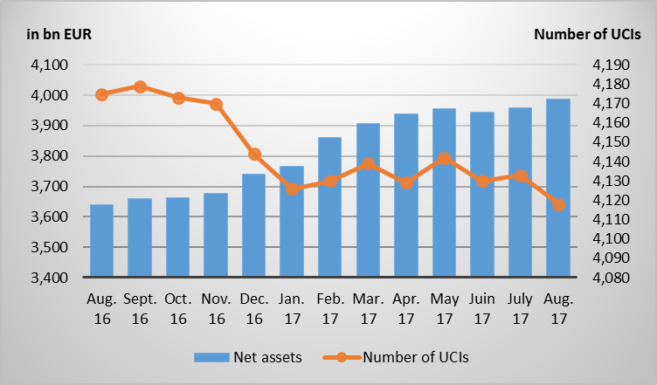

The number of undertakings for collective investment (UCIs) taken into consideration totals 4,118 as against 4,133 in the previous month. A total of 2,638 entities have adopted an umbrella structure, which represents 13,218 sub-funds. When adding the 1,480 entities with a traditional structure to that figure, a total of 14,698 fund units are active in the financial centre.
As regards, on the one hand, the impact of financial markets on the main categories of undertakings for collective investment and, on the other hand, the net capital investment within these UCIs, the following can be said about August.
The categories of equity UCIs developed differently during the month under review.
As far as developed countries are concerned, August was marked, on the one hand, by geopolitical tensions related to North Korea and, on the other hand, by good economic news in Europe, the United States and Japan. In the light of the above and in view of the EUR appreciation against the main currencies which weighed on the markets, the category of European equity UCIs performed negatively. Although the American and Japanese equity prices remained more or less stable, the depreciation of USD and JPY against EUR caused the US and Japanese equity UCI categories to end the month in negative territory.
As regards emerging countries, all categories of equity UCIs improved despite the geopolitical tensions in relation to North Korea. The Asian equity UCI category registered price increases amidst stable economic data in China and an overall favourable economic environment. Russia’s and Brazil’s recovery from the recession and good economic figures in several other Eastern European and Latin American countries as well as the stabilisation of oil and primary commodity prices sustained the positive performance of the Eastern European and Latin American equity UCIs.
During August, the equity UCI categories recorded, overall, a positive net capital investment.
Development of equity UCIs during the month of August 2017*
 | Market variation in % | Net issues in %
Global market equities | -0.35% | 0.33%
European equities | -0.86% | 0.21%
US equities | -1.00% | -0.97%
Japanese equities | -0.65% | 0.08%
Eastern European equities | 4.91% | 0.03%
Asian equities | 0.31% | 0.29%
Latin American equities | 3.73% | 0.47%
Other equities | 0.48% | 0.31%
* Variation in % of Net Assets in EUR as compared to the previous month.
In Europe, due to their safe-haven status, high-rated euro area government bond yields declined amid geopolitical tensions linked to North Korea. Lower-rated euro area countries recorded a more moderate decline in their government bond yields which widened the yield spreads between them and higher-rated euro area countries. In the wake of the rise in government bond yields, corporate bonds also registered price increases, so that EUR-denominated bond UCIs slightly appreciated.
In the United States, US government bond yields also decreased as a result of low inflation and the search by investors for safe-haven assets in the context of geopolitical tensions and uncertainties as regards US economic policy. Combined with the USD vs. EUR depreciation, the USD-denominated bond UCI category remained unchanged.
Overall, emerging countries bonds recorded price increases due to economic fundamentals which were stable on average, the recovery of world trade and the stabilisation of primary commodity prices. Consequently, the emerging countries bond UCIs ended the month up.
In August, fixed-income UCI categories registered an overall positive net capital investment.

Development of fixed-income UCIs during the month of August 2017*
 | Market variation in % | Net issues in %
EUR money market | -0.03% | 2.20%
USD money market | -0.81% | 2.09%
Global market money market | -1.32% | 5.01%
EUR-denominated bonds | 0.57% | 1.18%
USD-denominated bonds | 0.00% | 1.16%
Global market bonds | 0.28% | 0.54%
Emerging market bonds | 0.53% | 1.70%
High Yield bonds | -0.63% | 0.02%
Others | -0.04% | 1.49%
* Variation in % of Net Assets in EUR as compared to the previous month.
The development of net assets of diversified Luxembourg UCIs and of funds of funds is illustrated in the table below.
Development of diversified UCIs and Funds of Funds during the month of August 2017*
 | Market variation in % | Net issues in %
Diversified UCIs | -0.06% | 1.02%
Funds of Funds | -0.15% | 0.41%
* Variation in % of Net Assets in EUR as compared to the previous month.

II. Breakdown of the number and net assets of UCIs
 | PART I UCITS |  | PART II UCIs |  | SIFs |  | SUB-TOTAL  (without SICARs) |  | SICARs |  | TOTAL
 | NUMBER | NET ASSETS  (in bn €) | NUMBER | NET ASSETS  (in bn €) | NUMBER | NET ASSETS  (in bn €) | NUMBER | NET ASSETS  (in bn €) | NUMBER | NET ASSETS  (in bn €) | NUMBER | NET ASSETS  (in bn €)
31/12/2014 | 1,893 | 2,578.423 € | 422 | 168.915 € | 1,590 | 347.649 € | 3,905 | 3,094.987 € | 288 | 32.732 € | 4,193 | 3,127.719 €
31/01/2015 | 1,896 | 2,734.590 € | 412 | 178.286 € | 1,577 | 364.137 € | 3,885 | 3,277.013 € | 288 | 32.732 € | 4,173 | 3,309.745 €
28/02/2015 | 1,896 | 2,851.312 € | 409 | 181.463 € | 1,588 | 371.091 € | 3,893 | 3,403.866 € | 288 | 32.732 € | 4,181 | 3,436.598 €
31/03/2015 | 1,891 | 2,955.916 € | 405 | 186.664 € | 1,592 | 382.213 € | 3,888 | 3,524.793 € | 288 | 32.732 € | 4,176 | 3,557.525 €
30/04/2015 | 1,895 | 2,970.878 € | 403 | 185.177 € | 1,596 | 382.531 € | 3,894 | 3,538.586 € | 288 | 32.732 € | 4,182 | 3,571.318 €
31/05/2015 | 1,900 | 3,027.262 € | 401 | 187.084 € | 1,600 | 387.179 € | 3,901 | 3,601.525 € | 288 | 32.732 € | 4,189 | 3,634.257 €
30/06/2015 | 1,903 | 2,962.778 € | 399 | 182.163 € | 1,599 | 383.190 € | 3,901 | 3,528.131 € | 288 | 32.732 € | 4,189 | 3,560.863 €
31/07/2015 | 1,901 | 3,015.582 € | 392 | 181.228 € | 1,602 | 386.300 € | 3,895 | 3,583.110 € | 288 | 32.732 € | 4,183 | 3,615.842 €
31/08/2015 | 1,899 | 2,871.083 € | 391 | 173.038 € | 1,601 | 378.866 € | 3,891 | 3,422.987 € | 288 | 32.732 € | 4,179 | 3,455.719 €
30/09/2015 | 1,900 | 2,820.370 € | 391 | 169.729 € | 1,603 | 376.727 € | 3,894 | 3,366.826 € | 288 | 32.732 € | 4,182 | 3,399.558 €
31/10/2015 | 1,903 | 2,952.296 € | 391 | 173.421 € | 1,607 | 387.676 € | 3,901 | 3,513.393 € | 288 | 32.732 € | 4,189 | 3,546.125 €
30/11/2015 | 1,895 | 3,019.572 € | 386 | 175.406 € | 1,613 | 394.693 € | 3,894 | 3,589.671 € | 288 | 32.732 € | 4,182 | 3,622.403 €
31/12/2015 | 1,892 | 2,946.860 € | 384 | 169.896 € | 1,602 | 389.445 € | 3,878 | 3,506.201 € | 282 | 37.430 € | 4,160 | 3,543.631 €
31/01/2016 | 1,903 | 2,819.861 € | 378 | 164.531 € | 1,596 | 386.607 € | 3,877 | 3,370.999 € | 282 | 37.430 € | 4,159 | 3,408.429 €
29/02/2016 | 1,904 | 2,813.421 € | 373 | 157.278 € | 1,592 | 387.785 € | 3,869 | 3,358.484 € | 282 | 37.430 € | 4,151 | 3,395.914 €
31/03/2016 | 1,905 | 2,847.418 € | 371 | 157.047 € | 1,603 | 390.939 € | 3,879 | 3,395.404 € | 282 | 37.430 € | 4,161 | 3,432.834 €
30/04/2016 | 1,904 | 2,888.262 € | 370 | 159.477 € | 1,606 | 394.341 € | 3,880 | 3,442.080 € | 282 | 37.430 € | 4,162 | 3,479.510 €
31/05/2016 | 1,902 | 2,928.461 € | 371 | 159.174 € | 1,609 | 400.345 € | 3,882 | 3,487.980 € | 282 | 37.430 € | 4,164 | 3,525.410 €
30/06/2016 | 1,899 | 2,906.498 € | 367 | 156.893 € | 1,621 | 398.513 € | 3,887 | 3,461.904 € | 282 | 37.430 € | 4,169 | 3,499.334 €
31/07/2016 | 1,892 | 2,997.551 € | 365 | 159.356 € | 1,631 | 408.849 € | 3,888 | 3,565.756 € | 282 | 37.430 € | 4,170 | 3,603.186 €
31/08/2016 | 1,894 | 3,033.413 € | 363 | 159.141 € | 1,636 | 409.608 € | 3,893 | 3,602.162 € | 282 | 37.430 € | 4,175 | 3,639.592 €
30/09/2016 | 1,891 | 3,051.016 € | 362 | 159.088 € | 1,644 | 411.825 € | 3,897 | 3,621.929 € | 282 | 37.430 € | 4,179 | 3,659.359 €
31/10/2016 | 1,893 | 3,053.246 € | 356 | 159.320 € | 1,642 | 413.932 € | 3,891 | 3,626.498 € | 282 | 37.430 € | 4,173 | 3,663.928 €
30/11/2016 | 1,888 | 3,065.882 € | 355 | 158.862 € | 1,645 | 415.885 € | 3,888 | 3,640.629 € | 282 | 37.430 € | 4,170 | 3,678.059 €
31/12/2016 | 1,869 | 3,116.104 € | 353 | 160.578 € | 1,639 | 424.394 € | 3,861 | 3,701.076 € | 283 | 40.254 € | 4,144 | 3,741.330 €
31/01/2017 | 1,869 | 3,138.701 € | 351 | 160.967 € | 1,623 | 427.236 € | 3,843 | 3,726.904 € | 283 | 40.483 € | 4,126 | 3,767.387 €
28/02/2017 | 1,880 | 3,217.837 € | 351 | 164.858 € | 1,617 | 436.203 € | 3,848 | 3,818.898 € | 282 | 41.419 € | 4,130 | 3,860.317 €
31/03/2017 | 1,895 | 3,257.773 € | 346 | 165.780 € | 1,618 | 440.288 € | 3,859 | 3,863.841 € | 280 | 42.186 € | 4,139 | 3,906.027 €
30/04/2017 | 1,892 | 3,286.525 € | 342 | 164.471 € | 1,613 | 444.874 € | 3,847 | 3,895.870 € | 282 | 42.037 € | 4,129 | 3,937.907 €
31/05/2017 | 1,895 | 3,297.803 € | 342 | 162.813 € | 1,620 | 453.326 € | 3,857 | 3,913.943 € | 285 | 42.923 € | 4,142 | 3,956.366 €
30/06/2017 | 1,887 | 3,288.338 € | 338 | 160.634 € | 1,618 | 451.703 € | 3,843 | 3,900.675 € | 287 | 42.923 € | 4,130 | 3,943.598 €
31/07/2017 | 1,885 | 3,307.103 € | 338 | 159.097 € | 1,619 | 448.554 € | 3,842 | 3,914.754 € | 291 | 42.827 € | 4,133 | 3,957.581 €
31/08/2017 | 1,876 | 3,328.865 € | 337 | 156.448 € | 1,615 | 458.911 € | 3,828 | 3,944.224 € | 290 | 43.104 € | 4,118 | 3,987.328 €

During the month under review, the following 10 undertakings for collective investment have been registered on the official list:
- UCITS Part I 2010 Law:
- DEUTSCHE AM MULTI ASSET PIR FUND, 2, boulevard Konrad Adenauer, L-1115 Luxembourg
- INDOSUEZ ESTRATEGIA, 31-33, avenue Pasteur, L-2311 Luxembourg
- ITI FUNDS UCITS ETF SICAV, 20, boulevard Emmanuel Servais, L-2535 Luxembourg
- MASAYUME FUND, 49, boulevard du Prince Henri, L-1724 Luxembourg

- UCIs Part II 2010 Law:
- FRANKFURTER, 15, rue de Flaxweiler, L-6776 Grevenmacher

- SIFs:
- BANTLEON SIF SICAV, 33A, avenue J-F Kennedy, L-1855 Luxembourg
- BOUWFONDS EUROPEAN STUDENT HOUSING FUND II, 2, place François-Joseph Dargent, L-1413 Luxembourg
- FRANKLIN TEMPLETON ALTERNATIVE INVESTMENT FUNDS FCP-SIF, 8A, rue Albert Borschette, L-1246 Luxembourg
- NUCLEAR INVESTMENT FUND S.A. SICAV-SIF, 5, allée Scheffer, L-2520 Luxembourg
- OCEAN GROUP CAPITAL II, S.A. SICAV-SIF, 30, boulevard Royal, L-2449 Luxembourg

- SICARs:
- -

The following 25 undertakings for collective investment have been deregistered from the official list during the month under review:
- UCITS Part I 2010 Law:
- ACE ASSET MANAGEMENT - SICAV, 106, route d'Arlon, L-8210 Mamer
- CANDRIAM TOTAL RETURN II, 136, route d'Arlon, L-1150 Luxembourg
- CASTELL CONCEPT, 15, avenue J-F Kennedy, L-1855 Luxembourg
- DB OPPORTUNITY, 2, boulevard Konrad Adenauer, L-1115 Luxembourg
- DIAPASON COMMODITIES, 6, route de Trèves, L-2633 Senningerberg
- DMS UCITS PLATFORM FUND, 25-28, North Wall Quay, Dublin 1
- EUROSWITCH DEFENSIVE CONCEPTS OP, 2, boulevard Konrad Adenauer, L-1115 Luxembourg
- FIDELITY ALPHA FUNDS SICAV, 2A, rue Albert Borschette, L-1246 Luxembourg
- GLOCAP HAIG, 1C, rue Gabriel Lippmann, L-5365 Munsbach
- H & A STABILITÄTSWÄHRUNGEN, 1C, rue Gabriel Lippmann, L-5365 Munsbach
- PIONEER INSTITUTIONAL FUNDS, 8-10, rue Jean Monnet, L-2180 Luxembourg
- UNIPROFIANLAGE (2017), 308, route d'Esch, L-1471 Luxembourg
- UNIPROFIANLAGE (2017/II), 308, route d'Esch, L-1471 Luxembourg
- VAN ECK, 49, avenue J-F Kennedy, L-1855 Luxembourg

- UCIs Part II 2010 Law:
- ALBERGO, 15, rue de Flaxweiler, L-6776 Grevenmacher
- UNIGARANT: COMMODITIES (2017) II, 308, route d'Esch, L-1471 Luxembourg

- SIFs:
- AVIVA INVESTORS INTERNATIONAL FUND, 2, rue du Fort Bourbon, L-1249 Luxembourg
- FENICE SICAV-SIF SCA, 6A, rue Gabriel Lippmann, L-5365 Munsbach
- GLL EUROPA FONDS DES VERSORGUNGSWERKS DER RAE NRW, 15, rue Bender, L-1229 Luxembourg
- ICG ALTERNATIVE CREDIT (LUXEMBOURG) SICAV-SIF SCA, 5, allée Scheffer, L-2520 Luxembourg
- NORDIC RETAIL FUND, 2-8, avenue Charles de Gaulle, L-1653 Luxembourg
- RURAL IMPULSE FUND S.A., SICAV-FIS, 11, rue Aldringen, L-1118 Luxembourg
- TAURUS INVEST FCP-FIS, 26, avenue de la Liberté, L-1930 Luxembourg
- VALPIC, 15, avenue J-F Kennedy, L-1855 Luxembourg

- SICARs:
- OPTIMUM IMMO S.A., SICAR, 12, rue Eugène Ruppert, L-2453 Luxembourg

Mandatory use of legal entity identifier (LEI) under MiFID II/MiFIR and EMIR

Communiqué of 12 October 2017
With reference to the upcoming entry into force of Directive 2014/65/EU (MiFID II) and Regulation (EU) No 600/2014 (MiFIR), the European Securities and Market Authority (ESMA) released a statement providing information to the various entities required to use a Legal Entity Identifier (LEI).
In this context the CSSF would like to remind that, under the new EMIR reporting requirements, the LEI will be mandatory as of 1 November 2017 to identify the counterparty in a derivative transaction (i.e. reporting counterparty ID) and that, in order to accept the EMIR reports, trade repositories will check the LEI of the reporting counterparty with the GLEIF database.

STATISTICS

Banks

Decrease in the balance sheet total as at 30 June 2017
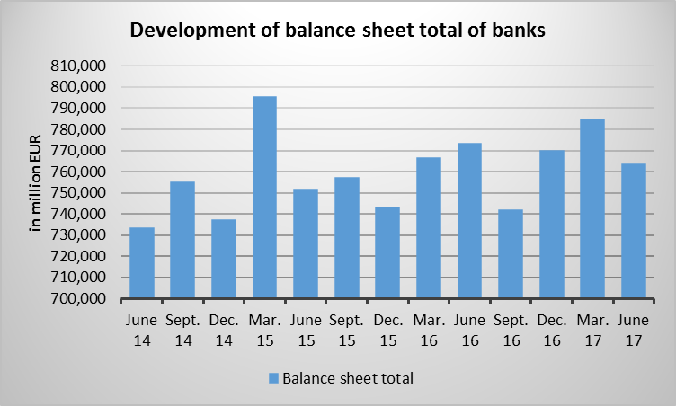

Investment firms

Decrease in the balance sheet total as at 31 August 2017
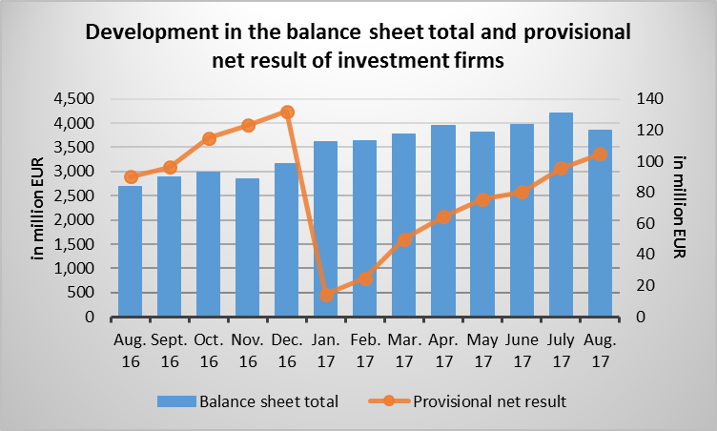

Specialised PFS

Decrease in the balance sheet total as at 31 August 2017
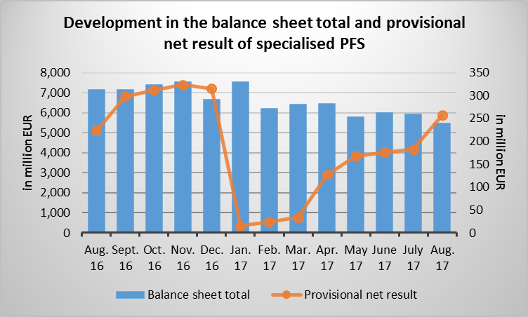

Support PFS

Increase in the balance sheet total as at 31 August 2017
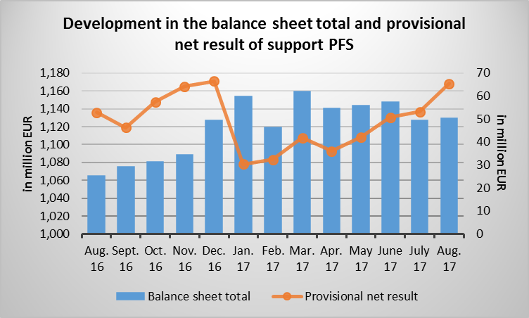

UCIs (Situation as at 31 August 2017)

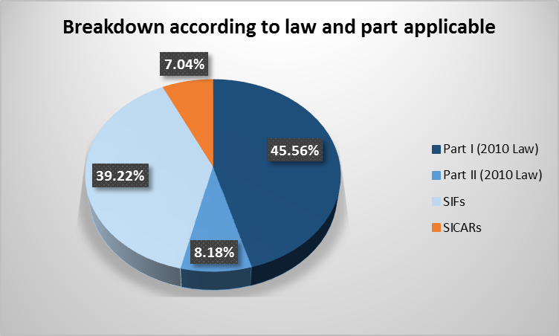
Number of UCIs
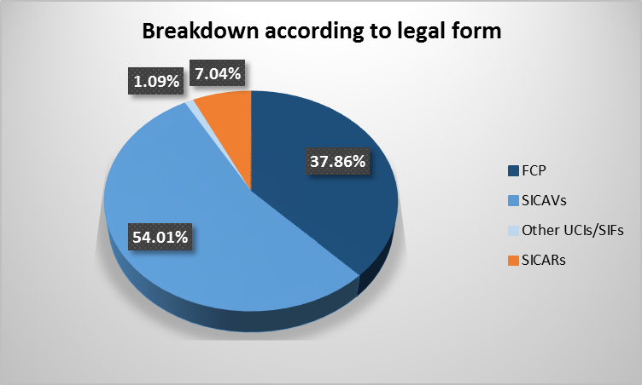
Law, part/legal form | FCP | SICAVs | Other UCIs/SIFs | SICARs | TOTAL
Part I (2010 Law) | 1,004 | 872 | 0 | 0 | 1,876
Part II (2010 Law) | 169 | 165 | 3 | 0 | 337
SIFs | 386 | 1,187 | 42 | 0 | 1,615
SICARs | 0 | 0 | 0 | 290 | 290
TOTAL | 1,559 | 2,224 | 45 | 290 | 4,118

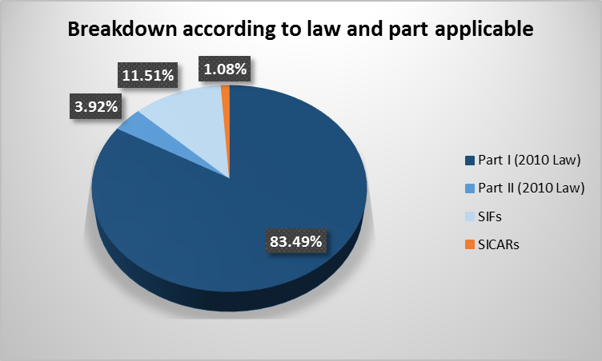
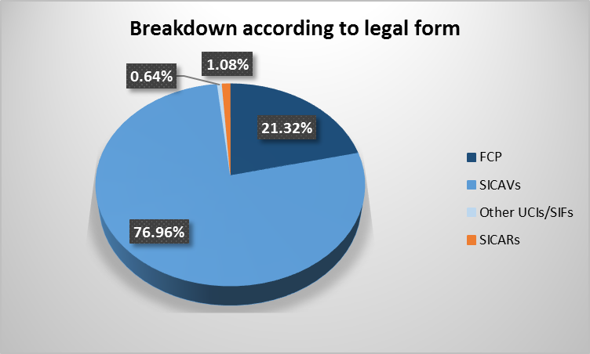
Net assets of UCIs

Law, part/legal form (in bn EUR) | FCP | SICAVs | Other UCIs/SIFs | SICARs | TOTAL
Part I (2010 Law) | 631.952 | 2,696.913 | 0.000 | 0.000 | 3,328.865
Part II (2010 Law) | 54.759 | 101.043 | 0.646 | 0.000 | 156.448
SIFs | 163.327 | 270.752 | 24.832 | 0.000 | 485.911
SICARs | 0.000 | 0.000 | 0.000 | 43.104 | 43.104
TOTAL | 850.038 | 3,068.708 | 25.478 | 43.104 | 3,987.328

Breakdown according to investment policy
Breakdown according to investment policy | Net assets  (in bn EUR) | Number of  fund units
Fixed-income securities | 1,208.378 | 3,146
Variable-yield transferable securities | 1,151.985 | 3,797
Mixed transferable securities | 862.906 | 4,029
Funds of funds | 241.798 | 2,154
Money market instruments and other short-term securities | 326.800 | 243
Cash | 1.747 | 20
Private equity | 29.304 | 192
Venture capital | 1.655 | 29
Real estate | 56.132 | 337
Futures and/or options | 12.696 | 126
Other assets | 50.823 | 223
Public-to-Private | 0.094 | 3
Mezzanine | 2.507 | 13
Venture Capital (SICARs) | 7.811 | 94
Private Equity (SICARs) | 32.692 | 292
TOTAL | 3,987.328 | 14,698

Breakdown of net assets according to investment policy and (the part) of their law
Breakdown by investment policy | NET ASSETS  (in bn EUR) | NUMBER OF  FUND UNITS | SUBSCRIPTIONS  (In bn EUR) | REDEMPTIONS  (in bn EUR) | NET SUBSCRIPTIONS  (in bn EUR)
PART I
Fixed-income transferable securities | 1,096.378 | 2,511 | 42.828 | 33.028 | 9.800
Variable-yield transferable securities | 1,089.980 | 3,407 | 32.612 | 31.284 | 1.328
Mixed transferable securities | 684.833 | 2,809 | 24.513 | 16.857 | 7.656
Funds of funds | 139.430 | 993 | 2.605 | 1.815 | 0.790
Money market instruments and other short-term securities | 306.775 | 185 | 116.967 | 107.819 | 9.148
Cash | 1.181 | 10 | 0.037 | 0.024 | 0.013
Futures and/or options | 6.790 | 57 | 0.203 | 0.108 | 0.095
Other assets | 3.498 | 10 | 0.028 | 0.025 | 0.003
TOTAL PART I: | 3,328.865 | 9,982 | 219.793 | 190.960 | 28.833
PART II
Fixed-income transferable securities | 25.793 | 115 | 0.355 | 0.511 | -0.156
Variable-yield transferable securities | 14.411 | 67 | 0.192 | 0.177 | 0.015
Mixed transferable securities | 56.922 | 228 | 1.102 | 2.242 | -1.140
Funds of funds | 30.596 | 299 | 0.224 | 1.270 | -1.046
Money market instruments and other short-term securities | 15.765 | 47 | 0.930 | 0.740 | 0.190
Cash | 0.550 | 8 | 0.016 | 0.010 | 0.006
Private equity | 4.576 | 15 | 0.112 | 0.037 | 0.075
Venture capital | 0.003 | 1 | 0.000 | 0.000 | 0.000
Real estate | 1.299 | 21 | 0.001 | 0.004 | -0.003
Futures and/or options | 2.939 | 29 | 0.032 | 0.052 | -0.020
Other assets | 3.594 | 13 | 0.061 | 0.052 | 0.009
TOTAL PART II: | 156.448 | 843 | 3.025 | 5.095 | -2.070
SIFs
Fixed-income transferable securities | 86.207 | 520 | 1.329 | 0.791 | 0.538
Variable-yield transferable securities | 47.594 | 323 | 0.394 | 0.347 | 0.047
Mixed transferable securities | 121.151 | 992 | 4.044 | 1.140 | 2.904
Funds of funds | 71.772 | 862 | 1.026 | 0.672 | 0.354
Money market instruments and other short-term securities | 4.260 | 11 | 0.569 | 0.206 | 0.363
Cash | 0.016 | 2 | 0.000 | 0.000 | 0.000
Private equity | 24.728 | 177 | 0.628 | 0.096 | 0.532
Venture capital | 1.652 | 28 | 0.013 | 0.011 | 0.002
Real estate | 54.833 | 316 | 1.316 | 0.570 | 0.746
Futures and/or options | 2.967 | 40 | 0.053 | 0.056 | -0.003
Other assets | 43.731 | 200 | 1.949 | 0.872 | 1.077
TOTAL SIFs: | 458.911 | 3,471 | 11.321 | 4.761 | 6.560
SICARs
Public-to-Private | 0.094 | 3 | 0.000 | 0.000 | 0.000
Mezzanine | 2.507 | 13 | 0.000 | 0.000 | 0.000
Venture Capital | 7.811 | 94 | 0.000 | 0.001 | -0.001
Private Equity | 32.692 | 292 | 0.000 | 0.024 | -0.024
TOTAL SICARs: | 43.104 | 402 | 0.000 | 0.025 | -0.025
TOTAL LUXEMBOURG UCIs: | 3,987.328 | 14,698 | 234.139 | 200.841 | 33.298

Origin of the initiators of Luxembourg UCIs
Country | Net assets  (in bn EUR) | in % | Number of UCIs | in % | Number of fund units | in %
United States | 817.427 | 20.5% | 182 | 4.4% | 1,062 | 7.2%
United Kingdom | 695.115 | 17.4% | 282 | 6.8% | 1,565 | 10.6%
Germany | 574.613 | 14.4% | 1,418 | 34.4% | 2,727 | 18.6%
Switzerland | 542.946 | 13.6% | 582 | 14.1% | 2,749 | 18.7%
Italy | 340.862 | 8.5% | 151 | 3.7% | 1,268 | 8.6%
France | 339.155 | 8.5% | 333 | 8.1% | 1,421 | 9.7%
Belgium | 170.474 | 4.3% | 173 | 4.2% | 981 | 6.7%
Netherlands | 93.702 | 2.4% | 52 | 1.3% | 240 | 1.6%
Luxembourg | 83.394 | 2.1% | 232 | 5.7% | 655 | 4.5%
Denmark | 79.750 | 2.0% | 24 | 0.6% | 186 | 1.3%
Others | 249.890 | 6.3% | 689 | 16.7% | 1,844 | 12.5%
TOTAL | 3,987.328 | 100.0% | 4,118 | 100.0% | 14,698 | 100.0%

Breakdown of UCI fund units registered in Luxembourg by reference currency
Currency | Net assets  (in bn EUR) | in % | Number of fund units | in %
AUD | 5.425 | 0.136% | 29 | 0.197%
CAD | 1.607 | 0.040% | 26 | 0.177%
CHF | 49.857 | 1.250% | 292 | 1.987%
CNH | 1.570 | 0.039% | 23 | 0.156%
CNY | 0.089 | 0.002% | 3 | 0.021%
CZK | 1.393 | 0.035% | 66 | 0.449%
DKK | 2.040 | 0.051% | 11 | 0.075%
EUR | 2,184.349 | 54.782% | 9,414 | 64.050%
GBP | 108.870 | 2.730% | 330 | 2.245%
HKD | 4.641 | 0.116% | 10 | 0.068%
HUF | 0.341 | 0.009% | 34 | 0.231%
JPY | 64.984 | 1.630% | 212 | 1.442%
NOK | 5.187 | 0.130% | 30 | 0.204%
NZD | 0.714 | 0.018% | 5 | 0.034%
PLN | 0.471 | 0.012% | 23 | 0.156%
RON | 0.517 | 0.013% | 5 | 0.034%
SEK | 48.870 | 1.226% | 181 | 1.231%
SGD | 0.381 | 0.010% | 3 | 0.021%
TRY | 0.079 | 0.002% | 3 | 0.021%
USD | 1,505.915 | 37.768% | 3,996 | 27.187%
ZAR | 0.028 | 0.001% | 2 | 0.014%
TOTAL | 3,987.328 | 100.000% | 14,698 | 100.000%

Pension funds
As at 10 October 2017, 13 pension funds in the form of pension savings companies with variable capital (SEPCAVs) and pension savings associations (ASSEPs) were registered on the official list of pension funds subject to the Law of 13 July 2005.
On the same date, the number of professionals authorised to act as liability managers for pension funds subject to the Law of 13 July 2005 amounted to 18.

Securitisation undertakings
The number of securitisation undertakings authorised by the CSSF in accordance with the Law of 22 March 2004 on securitisation amounted to 34 entities as at 10 October 2017.

Public oversight of the audit profession
The public oversight of the audit profession covered 59 cabinets de révision agréés (approved audit firms) and 304 réviseurs d'entreprises agréés (approved statutory auditors) as at 30 September 2017. The oversight also included 40 third-country auditors and audit firms duly registered in accordance with the Law of 23 July 2016 concerning the audit profession.

Prospectuses for securities in the event of an offer to the public or admission to trading on a regulated market (Part II and Part III, Chapter 1 of the Law on prospectuses for securities)

CSSF approvals
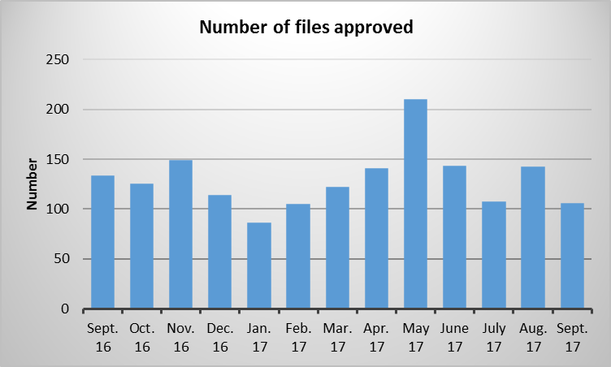
In September 2017, the CSSF approved a total of 106 documents pursuant to the Prospectus Law, which break down as follows:
base prospectus: | 20 | (18,87%)
other prospectuses : | 25 | (23,58%)
supplements : | 61 | (57,55%)

Notifications received by the CSSF from the competent authorities of other EEA Member States
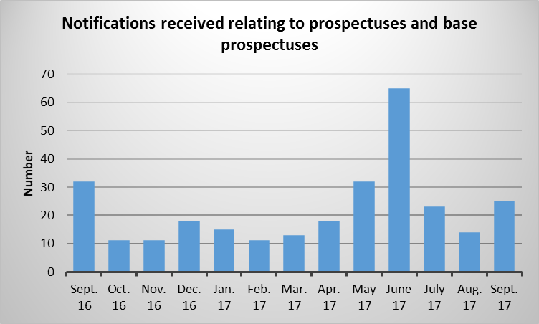
In September 2017, the CSSF received 25 notifications relating to prospectuses and base prospectuses and 42 notifications relating to supplements from competent authorities of other EEA Member States.

Notifications sent by the CSSF to competent authorities of other EEA Member States
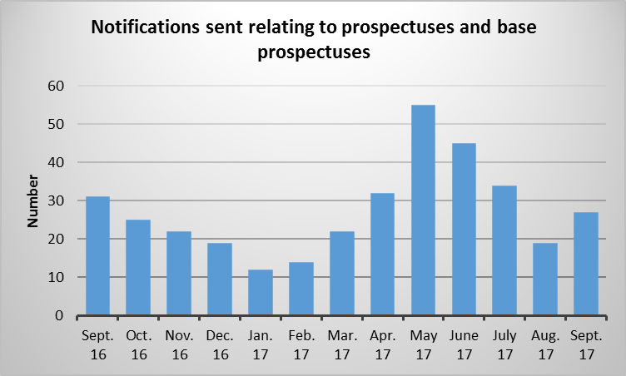
In September 2017, the CSSF sent 27 notifications relating to prospectuses and base prospectuses and 48 notifications relating to supplements to competent authorities of other EEA Member States..

Issuers of securities whose home Member State is Luxembourg pursuant to the Law of 11 January 2008 on transparency requirements for issuers (the "Transparency Law")
Since 12 September 2017, 2 issuers have chosen Luxembourg as home Member State for the purposes of the Transparency Law. Moreover, 11 issuers were deregistered from the list due to the fact that they no longer fall within the scope of the Transparency Law.
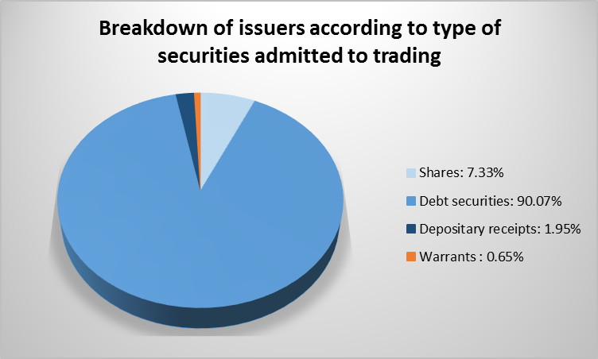
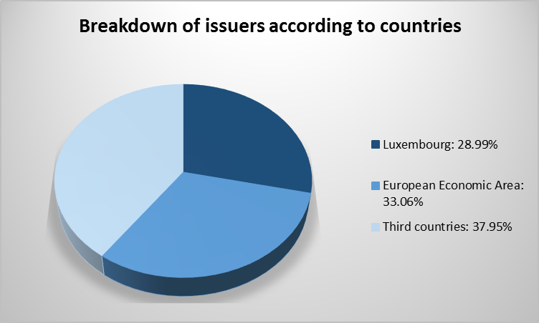
As at 10 October 2017, 614 issuers, subject to the supervision of the CSSF, were included in the list of issuers whose home Member State is Luxembourg pursuant to the Transparency Law.

WITHDRAWALS DECIDED BY THE CSSF
A decision to withdraw the specialised investment fund FUND HOUSE FCP SICAV-SIF from the official list of specialised investment funds was taken by the CSSF on 20 September 2017.
A decision to withdraw the specialised investment fund AKROS GLOBAL OPPORTUNITIES S.A., SICAV-SIF from the official list of specialised investment funds was taken by the CSSF on 28 September 2017.

FINANCIAL CENTRE

Main updated figures regarding the financial centre
Annual comparison
Banks | Number (10/10/2017) | 141 | no change
 | Balance sheet total (30/06/2017) | EUR 763.446 bn | EUR 9.821 bn
 | Profit before provisions (30/06/2017) | EUR 3.028 bn | EUR 25 m
Payment institutions | Number (10/10/2017) | 10 | 1 entity
Electronic money institutions | Number (10/10/2017) | 5 | 1 entity
UCIs | Number (11/10/2017) | Part I 2010 Law: 1,880 | 11 entities
 |  | Part II 2010 Law: 332 | 29 entities
 |  | SIFs: 1,608 | 41 entities
 |  | TOTAL: 3,820 | 81 entities
 | Number (30/09/2017) | SICARs: 290 | 7 entities
 | Total net assets (31/08/2017) | EUR 3,987.328 bn | EUR 347.736 bn
Management companies (Chapter 15) | Number (30/09/2017) | 202 | 2 entities
 | Balance sheet total (30/06/2017) | EUR 13.394 bn | 797 m
Management companies (Chapter 16) | Number (30/09/2017) | 173 | 4 entities
AIFMs | Number (11/10/2017) | 227 | 13 entities
Pension funds | Number (10/10/2017) | 13 | 2 entities
Authorised securitisation undertakings | Number (10/10/2017) | 34 | no change
Investment firms | Number (10/10/2017) | 105 of which 8 branches | 4 entities
 | Balance sheet total (31/08/2017) | EUR 3.849 bn | EUR 1.164 bn
 | Provisional net profit (31/08/2017) | EUR 104.775 m | EUR 14.595 m
Specialised PFS | Number (10/10/2017) | 113 | 13 entities
 | Balance sheet total (31/08/2017) | EUR 5.477 bn | EUR 1.671 bn
 | Provisional net profit (31/08/2017) | EUR 257.002 m | EUR 33.744 m
Support PFS | Number (10/10/2017) | 78 | 1 entity
 | Balance sheet total (31/08/2017) | EUR 1.130 bn | EUR 65 m
 | Provisional net profit (31/08/2017) | EUR 65.45 m | EUR 12.59 m
Issuers of securities whose home Member State is Luxembourg pursuant to the Transparency Law | Number (10/10/2017) | 614 | 68 entities
Public oversight of the audit profession | Number (30/09/2017) | 59 cabinets de révision agréés | 7 entities
 |  | 304 réviseurs d’entreprises agréés | 18 people
 |  | 40 third-country auditors and audit firms | 1 entity
Employment (30/06/2017) | Banks | 26,133 people | 100 people
 | Management companies (Chapter 15) | 4,192 people¹⁰ | 318 people
 | Investment firms | 2,278 people | 15 people
 | Specialised PFS | 4,103 people | 272 people
 | Support PFS | 9,202 people | 306 people
 | TOTAL | 45,908 people | 811 people

Due to major changes in the banking prudential reporting in 2016 and 2017 (Circular CSSF 15/621), the aggregation scope has been adapted to better reflect the evolution of the profit and loss accounts of Luxembourg banks. Consequently, the figures for June 2016 have been readjusted to reflect a larger aggregation scope which is similar to the new reporting of June 2017.
Including dividends received.
Since the statistical data of SICARs were published only on an annual basis before December 2016, the chart includes the number and net assets of SICARs as at 31 December 2015 for the previous months, resulting in constant figures until November 2016 for these vehicles.
Before 31 December 2016, the statistical data of SICARs were published on an annual basis only.
Undertaking for collective investment, the designated management company of which was authorised by the competent authorities of another Member State in accordance with Directive 2009/65/EC.
Commission Delegated Regulation (EU) 2017/104 and Commission Implementing Regulation (EU) 2017/105.
“Fund units” refers to both traditionally structures UCIs and sub-funds of umbrella funds.
These figures reflect the number of prospectuses, base prospectuses and supplements for which the CSSF sent one or several notifications. Where notifications were sent at different dates and/or in several Member States, only the first notification is included in the statistical calculation. Each document notified in one or several Member States is thus only counted once.
A difference with the number stated in the application “Supervised entities” may occur. This difference is due to the fact that the list in the application includes the banks that are already closed, but whose closure has not yet been confirmed by the ECB.
Preliminary figures.
This development does not mean a net creation or loss of jobs, but includes the transfer of existing jobs from the non-financial sector to the financial sector and vice versa.

